The ICE Cases – Search and Scenario Tool https://icedb.shinyapps.io/icedb/

About the ICE Cases

The Inventory of Environmental Conflict (ICE) is a collection of about 300 cases studies that are coded on 16 differing categories. If you have a moment, try out the new Search and Scenario Creator Tool based on the cases. The idea is that when a new case of conflict and environment occurs (or just if you want do do case-based research), you can input the categorical attributes in the cases and search the ICE cases for matches using a system of pattern matching.

The ability to analyze the cases vis-a-vis other cases allows decision-makers, and researchers, the ability to seek best and worst examples for guiding policy based say on outcomes of fatality levels. The cases themselves also have value as a group of data that can be analyzed.

Search and Scenario User Guide

https://icedb.shinyapps.io/icedb/

The ICE Search and Scenario Tool (SST) uses a web site and a programming package called R. One R package allows the coding of a sophisticated sorting and analysis system: Shiny. Along with some programming, we have built the site on a web server that R maintains. The site remains in a sleep mode until it needs to be used. Simply re-load the page to wake it up and use it.

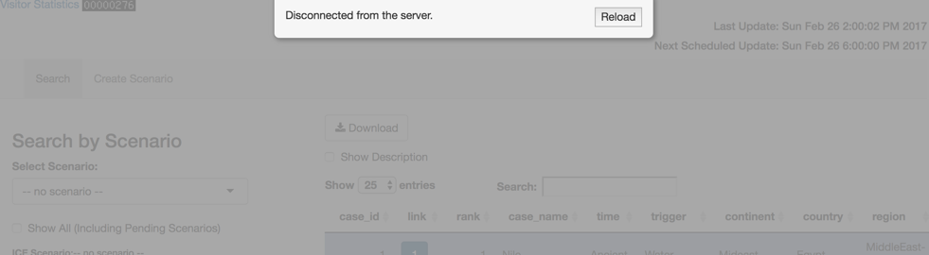

1. Search the ICE Cases

Here are the basic ICE cases that can be searched on the basis of attributes and weighted accordingly. Here is the basic screen that will appear (see Figure 1). There are several basic Search Options:
>Show Case Descriptions (Abstracts)
>Search the Descriptions by Key Word
>Choose Number of Cases to Show
>Download Inputs and Outputs

A “No Scenario” search is essentially a way to search the ICE cases. You could put in one or more attributes as a way to sort the cases. In this way, the site is both a repository for searching the ICE cases as well as a way to assess new instances of conflict and environment (and perhaps eventually add them to the case set). The text search looks at the case abstracts only.

Figure 1: The Basic ICE Cases and How to Search Cases
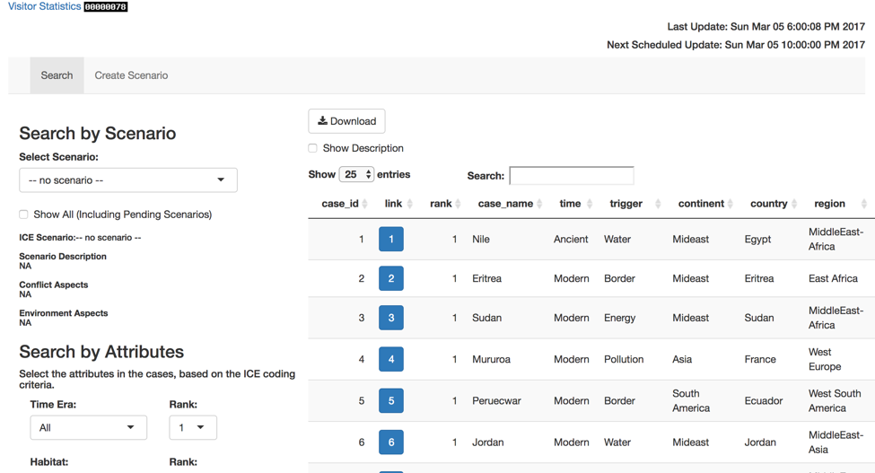

2. Deep Search the ICE Cases

In addition to searching the ICE cases based on attributes, it is also possible to change how you weight the attributes you select for (see Figure 2). For researchers and policy makers, interests might be limited to certain areas, problems, types of conflict, or other factors. Each attribute can be rated on a scale of 1 to 10. The default setting is one.

Figure 2: The Basic ICE Cases and How to Search Them Based on Attributes and Weightings

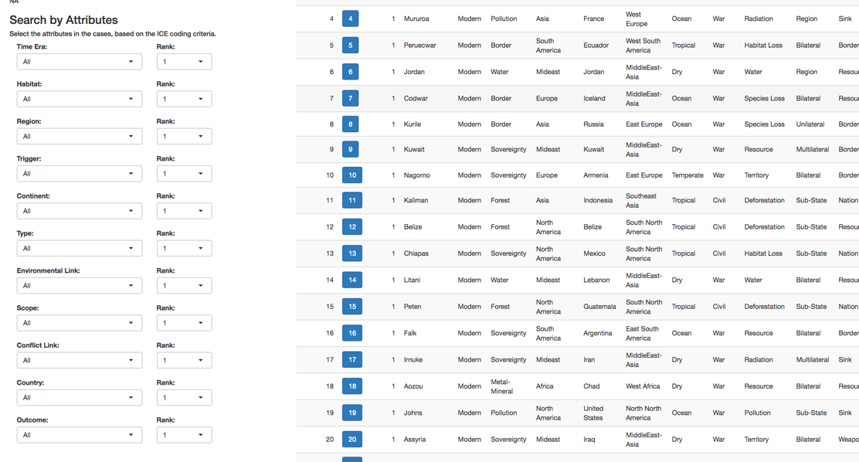

3. Search By Existing Scenarios
Anyone can build a scenario on the site and add it to a list of scenarios that are available. It will not be immediately posted as some site updates are set in a timed or approved mode. Some examples of new cases of environment and conflict are used to illustrate how the scenario builder can be used to track new cases as they arise and evolve (see Figure 3). The examples show how the rankings can be selected by attributes and weighted. This particular instance examines other cases similar the current dispute underway in the South China Sea.

Figure 3: The ICE Cases Ranked Using a Scenario
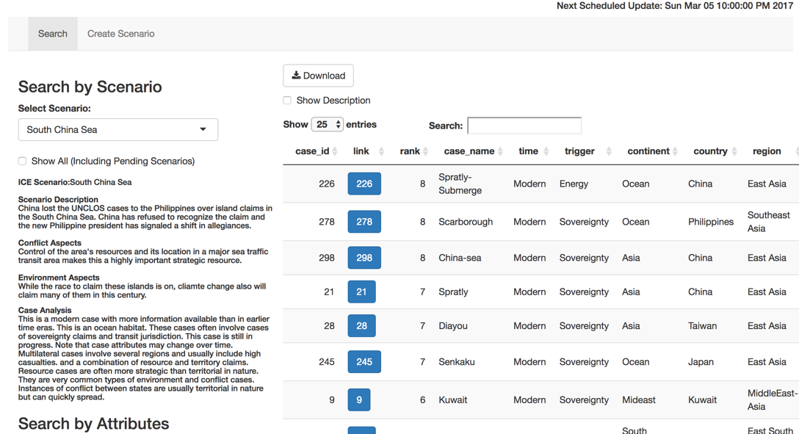

4. Create Your Own Scenario

You can create your own scenario and add to the list of the ICE scenarios (see Figure 4). Here, you would submit a case (it could be old or new) and have a list of related cases that are similar to it on a number of dimensions. As one begins to understand a case, this can only help in putting together some comparative information (see Figure 4). Creating a scenario involves both textual information (describing the case), along with a coding of prospective case attributes and their possible weightings. You will need to fill in some basic information about the environment and conflict aspects of the case.

Figure 4: How to Create an ICE Scenario

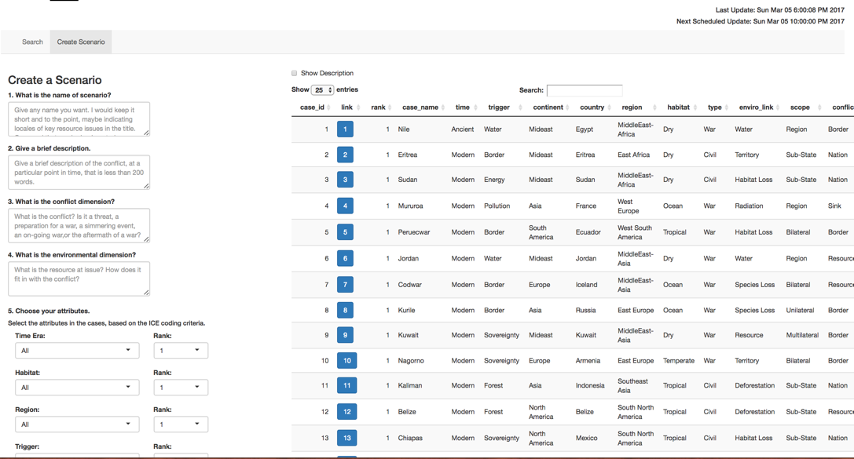

5. Save Your Own Scenario

You can save any scenario. If it is the default scenario you will get the basic attributes of ICE cases in one file and another file will provide the results. In this instance, the user will get a listing of all the cases. The cases are downloaded as “csv” files and you can use in most any spreadsheet program, starting with Excel.

If you create a scenario, your input choices (attributes and weightings) along with a ranked set of cases will be available for download. All new scenarios must be approved before posting so your choices will not be immediately available. New postings and changes to the database are update periodically during the day.

Figure 5: ICE Basic Choices

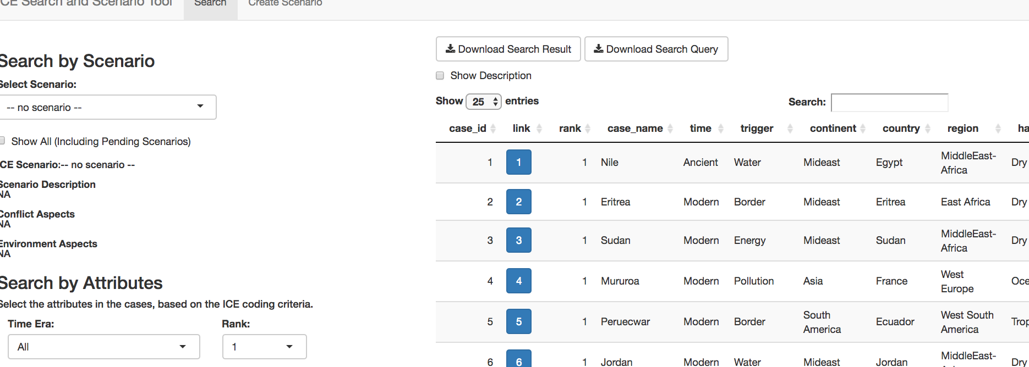

6. Saving Scenarios

After you have described the case and given it a name, you then select attributes to the prospective cases. You do not have to select on every category. Each selection can also be weighted (see Figure 6).

Figure 6: Save a Scenario

You can save the results of scenarios as well. Results will be exported to excel in two files. One file contains the input scenario (or default) case attributes while the other has the sorts of the ICE case on the basis of the case pattern matching scores.

The Full ICE Cases Coding Construct

I. Case Background
1. Abstract
2. Description
3. Duration
4. Location
5. Actors
II. Environment Aspects
6. Type of Environmental Problem
7. Type of Habitat
8. Act and Harm Sites:
III. Conflict Aspects
9. Type of Conflict
10. Level of Conflict
11. Fatality Level of Dispute (military and civilian fatalities)
IV. Environment and Conflict Overlap
12. Environment-Conflict Link and Dynamics:
13. Level of Strategic Interest
14. Outcome of Dispute:
V. Related Information and Sources
15. Related ICE Cases
16. Relevant Websites and Literature

